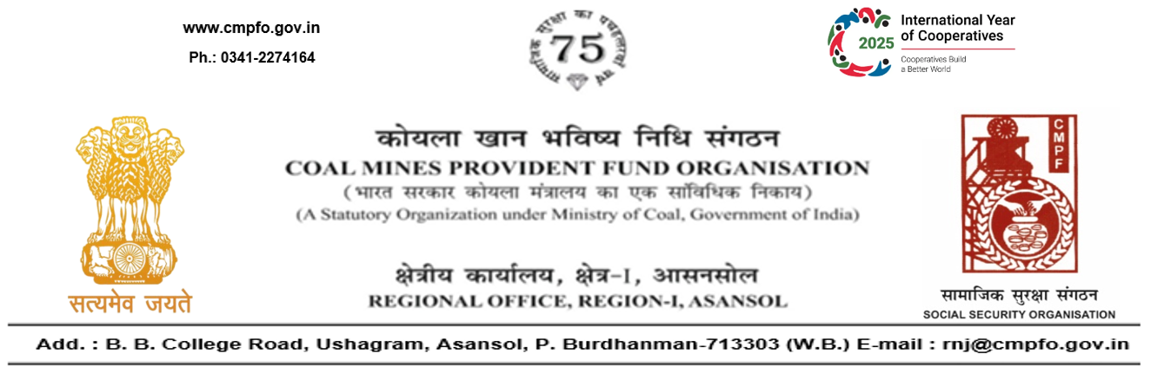
CPF/118/Misc/Ext-out/R-I/ASN/ Date 13/01/2026

To
The Regional Commissioner-I,
Coal Mines Provident Fund Organisation,
Sreepat Road, Sub P.O. SECL,
Bilaspur, Chhatisgarh- 495006
Sub- Supply of Extract of "VV" statement

Ref:- Your office letter no. CPF/BLP 75/Misc/2409 dated24/12/2025.

Sir,
On the subject and reference cited above, please find enclosed herewith the extract in respect of Shri Upendra Rai, CMPF A/C No- KTS/17/169 as desired.

Yours faithfully,

(Ajay Kumar Singh)
Encl- As above Regional Commissioner - I

